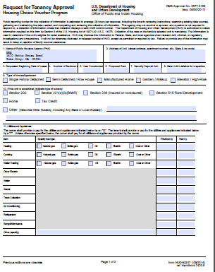
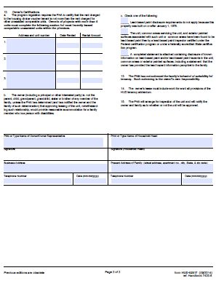

- Regional Housing Authority
- Full Address of the unit
- Proposed move-in date
- # of Bedrooms
- Year built
- $$ Monthly Rent
- $$ Amount of deposit
- Date unit will be ready for inspection
- Check the box for unit type
- Landlord will know if unit is subsidized (not common)
- “Fuel type” how is it powered, “Provided by” if tenant has to provide anything put a “t”, otherwise put an “o” for provided by owner
“Paid by” anything paid by tenant put a “t”, anything paid by owner put an “o”

- Not required
- Information for owner
- Information for owner
- Information for owner

Both the Owner and Tenant must fill out and sign their sections.

